PASTA ITALIANA
Quelques photos et une liste (non exhaustive car on a l’impression que les noms de pâtes ne font pas partis d’un ensemble fini !!)
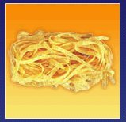Tagliatelle | Bucatini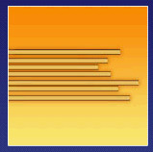 | 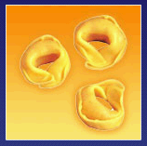Tortellini
Orecchiette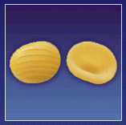 | Farfalline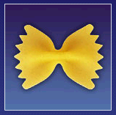 | Tortiglioni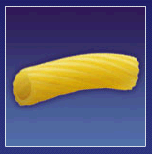
Casarecce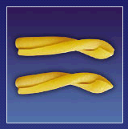 | 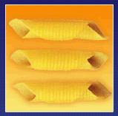Garganelli | 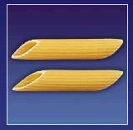Mezze penne
Spaccatelle | Cellentani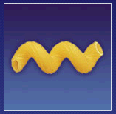 | Fusili spirale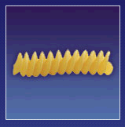
Ditaloni lisci | Ruote | Pipe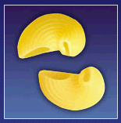
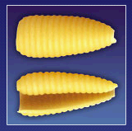Castellane (gnochi sarde) | Zite | Papardelle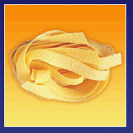
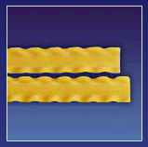Reginette | 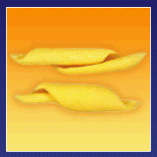Ricciogli di sfoglia | Tripolini

Other types :
BARBINE, BAVETTE, BIGOLI, BUCATINI, CANALINI, CANEDERLI, CAPELLINI, CASARECCE, CASTELLANE, CATENESELLE, CELLENTANI, CHIFFERI, CHITARRE, CONCHIGLIE, DITALONI, FAGIOLATA, FARFALLINE, FETTUCIA, FETTUCINE, FILINI, FIOCCHI, FUSILI, GARGANELLI, GEMELLI, GNOCCHI, GRANIGNA, GRATTINI, LASAGNE, LINGUE DI PASERO, LINGUINE, MACCHERONI, MALTAGLIATI, MANICHE, ORECCHIETE, PAPARDELLE, PENNE, PIPE, RAVIOLI, REGINETTE, RICCIOGLI DI SFOGLIA, RIGATONI, RUOTE, SEDANI, SPACCHATELLE, SPAGHETTI, STROZZAPRETI, TAGLIERINI, TAGLIATELLE, TEMPESTINA, TORTELLINI, TORTELLONI, TORTIGLIONI, TRENETTE, TRIPOLINI, VERMICELLI, ZITE…..

And then, each of these types can be :
Lisce or rigate, (lissés or hachurées)
-ino, -ette or -one, (small or big)
with eggs or without eggs,
lunga or mezze, ….

(long or half)

Web sites :
- I want to thank http://www.barilla.com where I found all these images.
But Barilla doesn’t have all the types given above !!

- If you want to order italian food and drink, here is an italian web sites that even italian people use : http://www.esperya.com/

